## ASP.NET Core

ASP.NET is a popular web-development framework for building web apps on the .NET platform.

ASP.NET Core is the open-source version of ASP.NET, that runs on macOS, Linux, and Windows. ASP.NET Core was first released in 2016 and is a re-design of earlier Windows-only versions of ASP.NET.

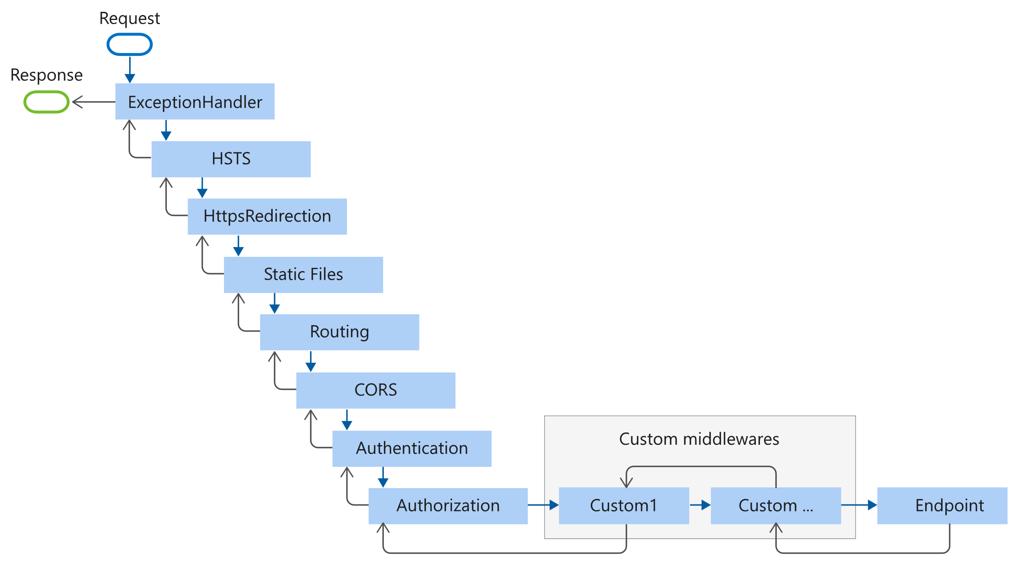

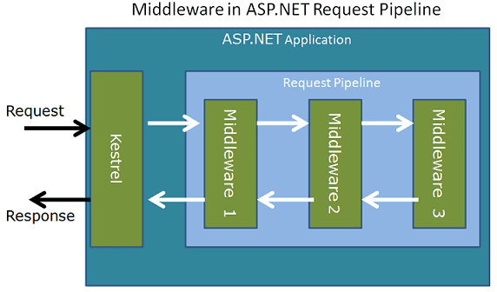

**Opening a asp.net core project:**

Create new project->asp.net core web api

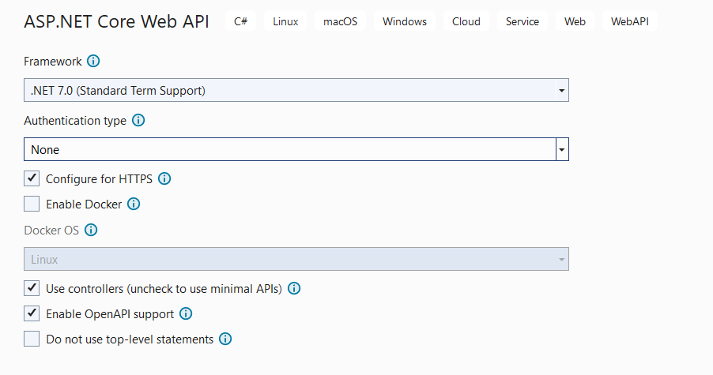

**Program with inline middleware:**

var builder = WebApplication.CreateBuilder(args);

var app = builder.Build();

app.Use(async (context, next) => {

await context.Response.WriteAsync(" My Middleware A1 \n");

await next();

await context.Response.WriteAsync(" My Middleware A2 \n");

});

app.Use(async (context, next) => {

await context.Response.WriteAsync(" My Middleware B1 \n");

await next();

await context.Response.WriteAsync(" My Middleware B2 \n");

});

app.UseMiddleware<MiddleC>();

app.UseMatafHeaderCheckerMiddleware();

app.Run(async (context) => {

await context.Response.WriteAsync(" APP RUN \n");

});

app.Run();

**Program with class middleware:**

public class MiddleC

{

public RequestDelegate _next;

public MiddleC(RequestDelegate next)

{

_next = next;

}

public async Task Invoke (HttpContext context)

{

await context.Response.WriteAsync(" Middle C\n");

await _next(context);

}

}

**Injecting object:**

app.Use<LoggerMiddleware>(new LoggerMiddleware ());

**Queries:**

if (context.Request.Method == HttpMethods.Get && context.Request.Query["custom"] == "1")

{

await context.Response.WriteAsync(" My Middleware custom \n");

}

<https://localhost:7238/?custom=1>

if (context.Request.Path ==”/short”)

{

…  
}

https://localhost:7238/short

builder.Services.AddSingleton<Core.ILogger, Logger>();

**Task:**

**1.**

Write 2 middlewares, first that add a new header to request, second that check if the middleware exist, if not, don't go on with the pipeline.

httpContext.Request.Headers.Add("Token", "fffff");

2.

Create Files Controller that has 2 api methods.One that Returns list of directory names/And One that creates a list of Myfiles objects in a specific folder..MyFiles Objects have 2 properties: FileName, FileSize.